**Data Profiling on Company Financial Data in SAP Data**

1. Sample Financial Data imported in MetaData explorer

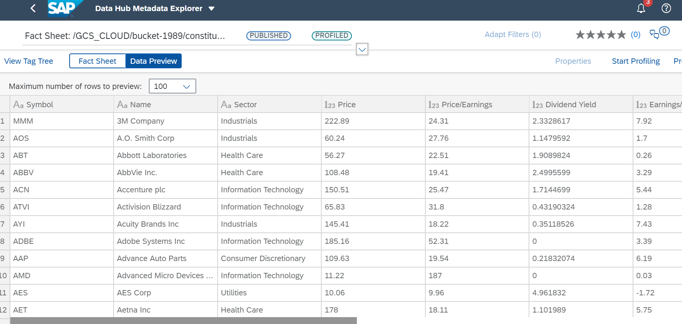

1. After Profiling the financial Data :

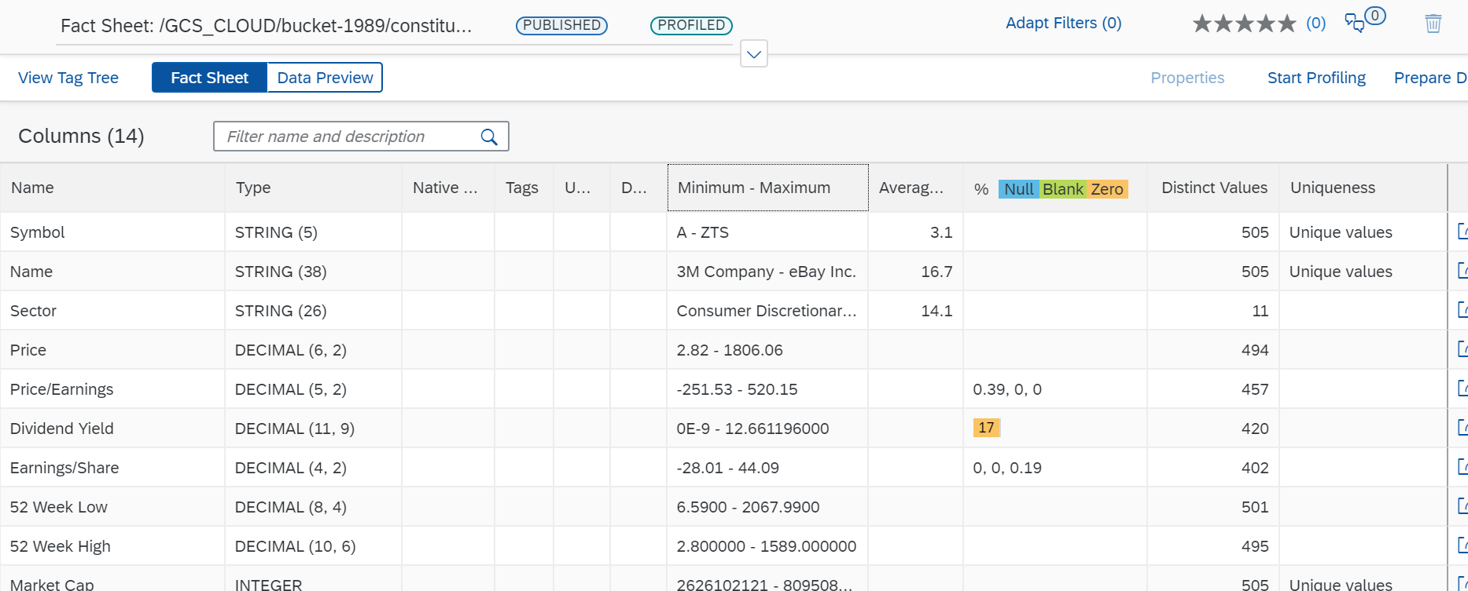

Graphical Representation of Data column wise.

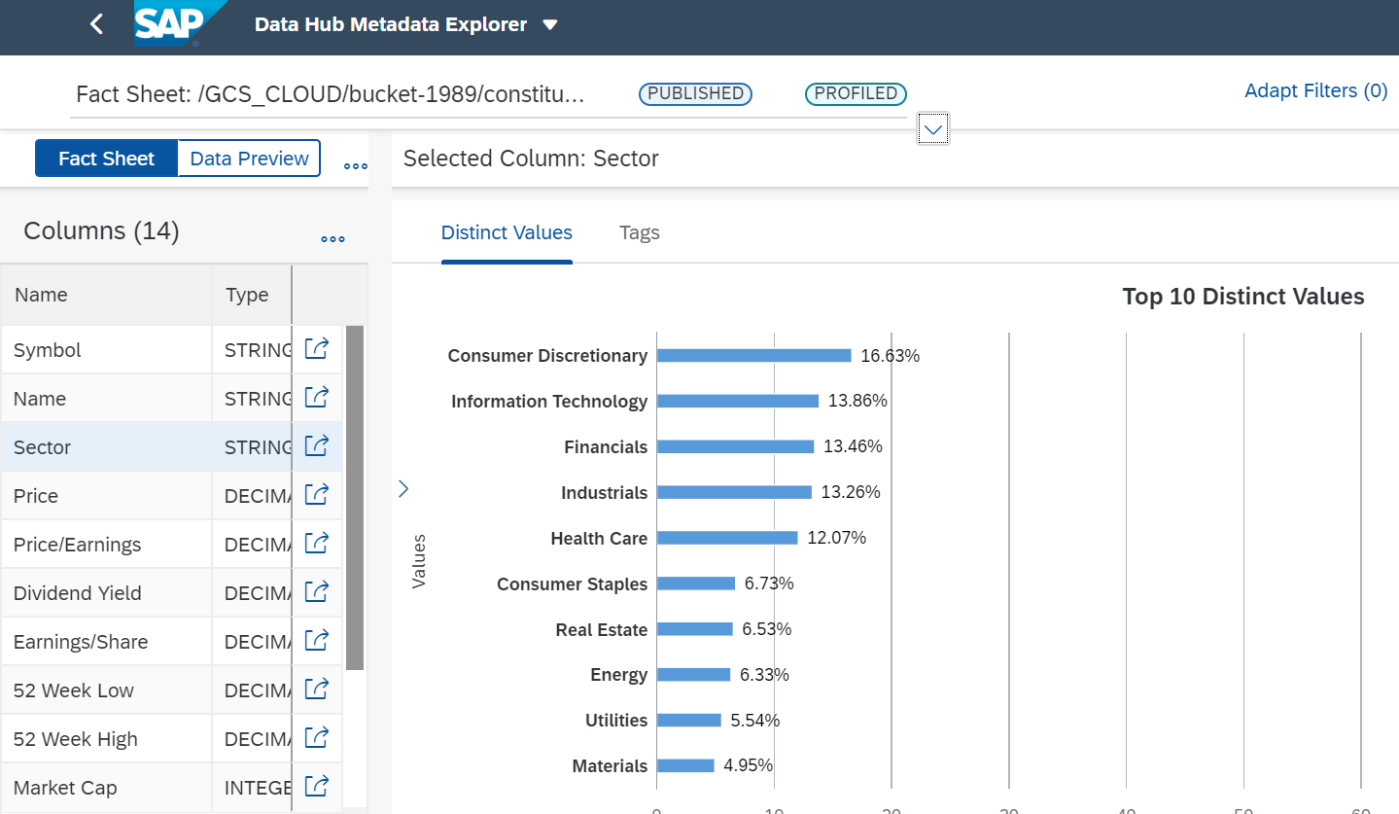

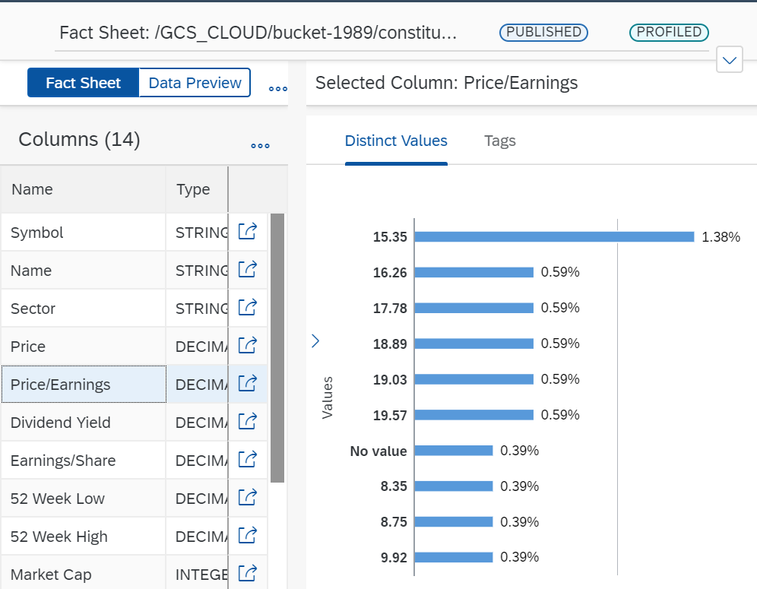

3.Created some rules for the Financial Data Set and added in one rule Book.

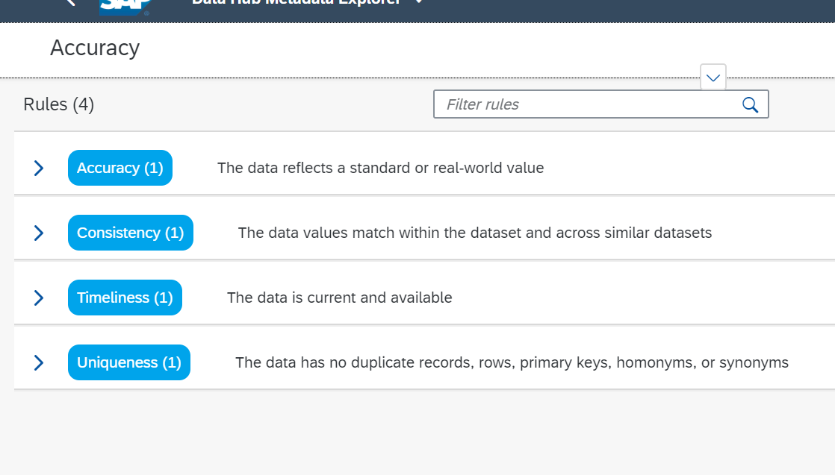

4.After running all the rules on the Data set will get the Percentage Accuracy of the Data

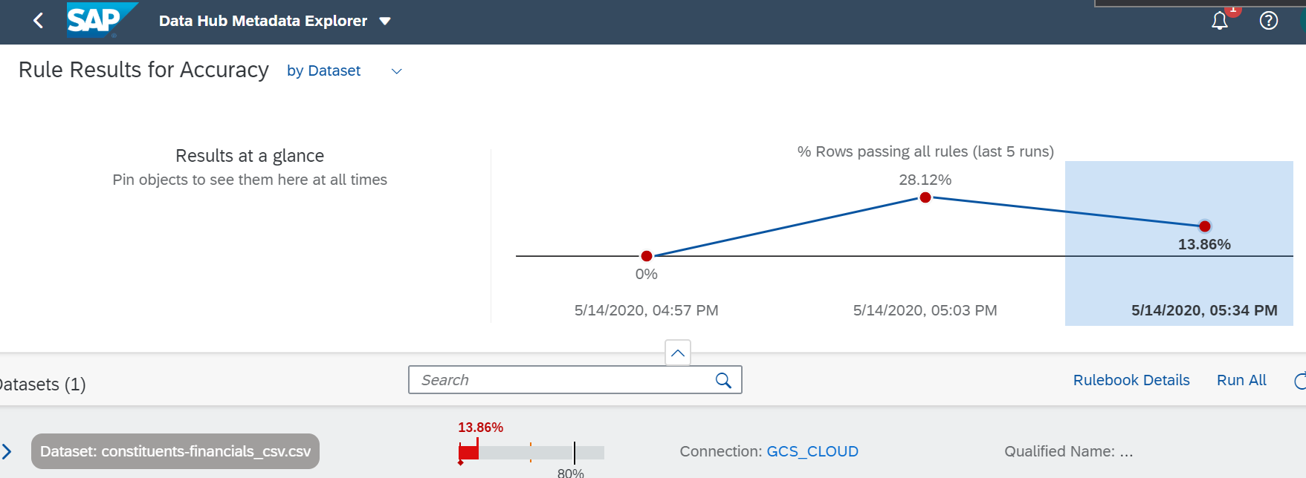

5. We can also view accuracy of Data set on the basis of Rules.

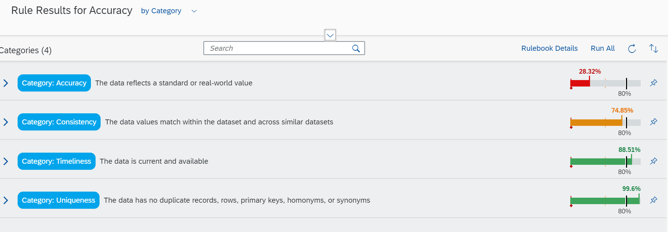

6. We can create dashboard further to get data set score and can also compare different Data sets.

